Software Engineering Project

Software for Dynamic Visualization of Cluster Synchronization in large networks

**Software User Manual**

**TABLE OF CONTENTS**

1. **INTRODUCTION**
2. **INSTALLATION INSTRUCTIONS**
3. **USING THE SOFTWARE**
4. **LIMITATIONS**

Introduction:

This software is designed for usage in complex systems lab to visualize

clustering of nodes according to given initial conditions and parameters provided as input.

It facilitates the user to see changes in state of the system in the form of Node vs. Node

diagram and also enables the user to see the time evolution series of a set of nodes.

This document serves as a guide for installation of necessary packages/dependencies for running this software and also gives guidelines for getting the software up and running on your system.

**Installation Instructions:**

**1) Windows**

**Part 1 – Setting up Python**

1). Download python 2.7.11 form the link mentioned below. <https://www.python.org/downloads/release/python-279/>

2). The downloaded file should be named as ‘python-2.7.9.msi’, open this installer and follow the basic instructions to install python.

3). Now right click on my computer, select properties.

4). Now select ‘Advanced system settings’.

5). Select ‘Environment Variables’.

6). Double click on path and in the variable value column, add ‘;C:/Python27’ at the end of existing value.

7). To check the successful installation of python, open cmd and type the command ‘python’.

**Part 2 – Installing Additional Package – Numpy 1.11.0**

1). Download numpy-1.11.0-cp27-none-win32.whl from the link mentioned below. <https://pypi.python.org/pypi/numpy>

2). Open cmd and type the following command.

pip install C:/…./numpy-1.11.0-cp27-none-win32.whl

Note: ‘C:/…./’ needs to be replaced by the address of the downloaded file.

**Part 3 – Installing Additional Package – Matplotlib 1.5.1**

1). Download matplotlib-1.5.1-cp27-none-win_amd64.whl from the link mentioned below. <https://pypi.python.org/pypi/matplotlib>

2). Open cmd and type the following command.

pip install C:/…./ matplotlib-1.5.1-cp27-none-win_amd64.whl

Note: ‘C:/…./’ needs to be replaced by the address of the downloaded file.

**2) Linux**

**Part 1 – Setting up Python**

1). Linux distributions have Python installed by default.

**Part 2 – Installing pip (if not installed)**

1). Open a terminal.

2). Type: sudo apt-get update

3). Type: sudo apt-get -y install python-pip

**Part 3 – Installing Additional Package – Numpy**

1). Open a terminal

2). Type: pip install –user numpy

**Part 4 – Installing Additional Package – Matplotlib 1.5.1**

1). Open a terminal

2). Type: pip install –user matplotlib

**3) Mac OSX**

Python and all the necessary packages required to run this software come pre-installed on Mac OSX

**Using the Software:**

**1) Windows**

1). Place the ClusterVisualizer folder in C: drive

2). Then place the network file (Name it as “net_adj.dat”). The network file should be an adjacency list and **NOT** a matrix.

3). Double click the Run.bat file in the folder to start the software.

**2) Linux/Mac OSX**

1). Place the ClusterVisualizer Folder on Desktop.

2). Then place the network file (Name it as “net_adj.dat”). The network file should be an adjacency list and **NOT** a matrix.

3) Run (Double Click) the Run.sh file to use the software.

On running the software, a dialog box appears with text fields for necessary inputs.

Provide the appropriate input and click the button of the required functionality.

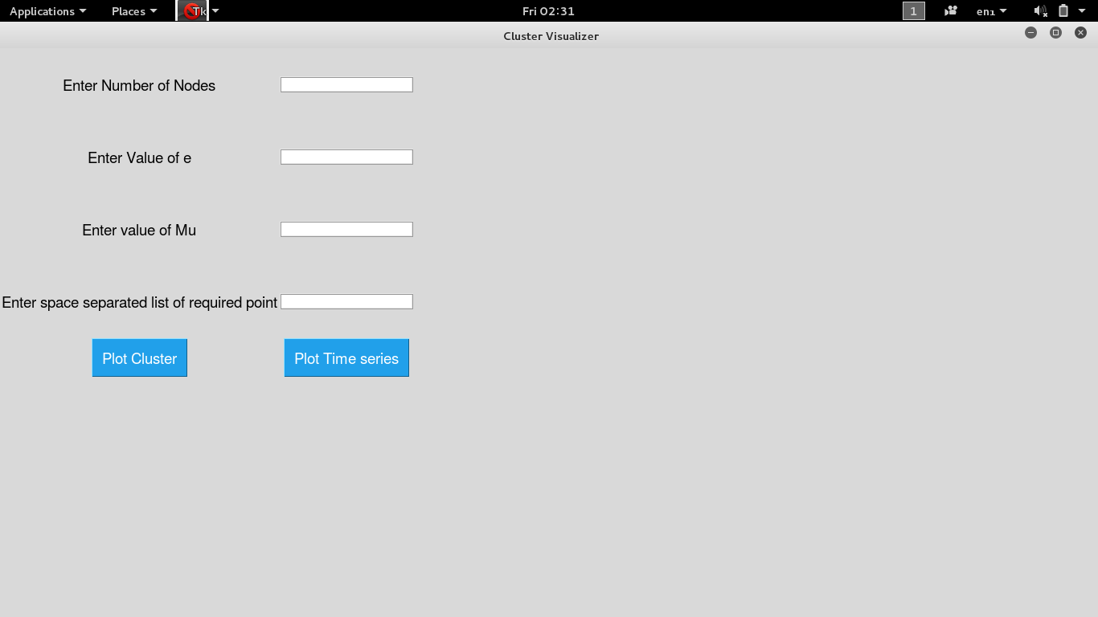

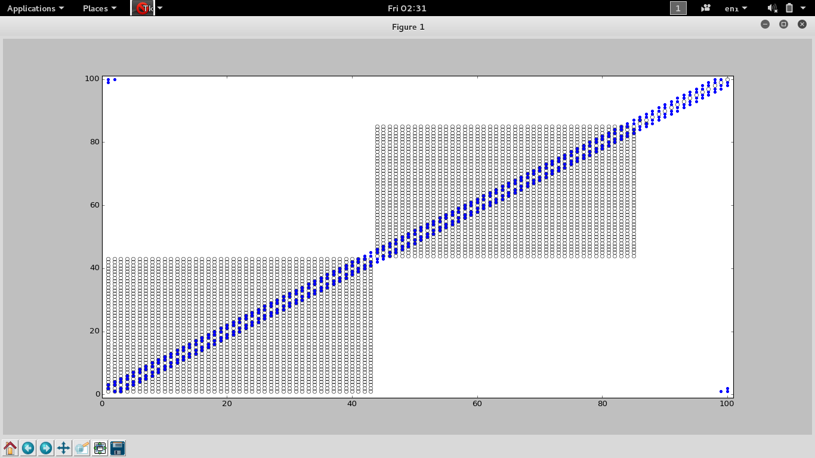

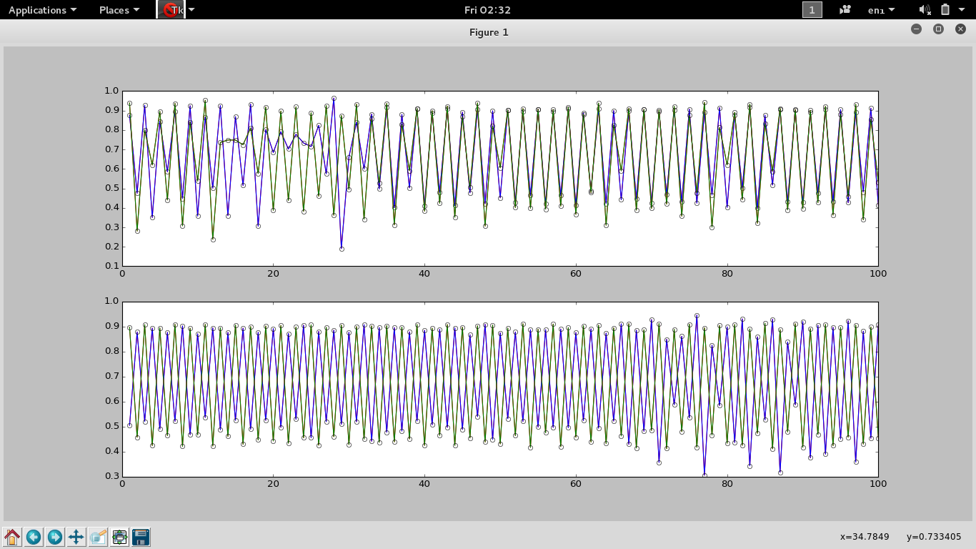

**Limitations:**

The software works smoothly for all networks with sizes up to 100 nodes. Thereafter the performance of the software starts declining (due to increased complexity) and the rate of plot generation declines.

For time series plot, the time series for 4 nodes can be viewed comfortably. Thereafter, due to increase in number of graphs, the plot windows becomes too cluttered making the series analysis difficult.

**If you have a problem:**

In case of any queries regarding the software, kindly reach the developer team

Project Team:

Varun Joglekar : cse140001037@iiti.ac.in

Lalit Gautam : cse140001016 @iiti.ac.in

Maharshi Sevak: cse140001018 @iiti.ac.in

Sri Harsha : cse140001021 @iiti.ac.in

Thank you for using our software.